# Data Types:

1. Value Type.
2. Reference Type.

## Value Type:

* Int.
* Float.
* Char etc.

## Reference Type:

* Classes . (User Defined Data Type)

# Objects:

* Object is a Instance of a Class.
* An Object is a tangible(solid) entity such as cars , table or a briefcase.
* Every Object has some characteristics (variables , Data Members ,Instance Variables) and capable of performing some actions (Methods , Function , Data Methods).
* The NEW key word assign the location in the memory to the object .
* Instance variables are different for every instance or Object of a Class.
* By Default every method or variable is private (Access Modifier).

# Constructer:

* Constructer is a special member function of a class.
* It is called whenever we created a new Object of a Class no requirement to call.
* Same name as that of Class.
* It has no return Type.
* Compiler automatically construct a
* Two Types of Constructers :  
  1. Default Constructor.

2. Parametrized Constructor.

## Default Constructor:

* A constructor which has not defined any parameter.
* Called without parameter.
* Initialize the same value to the every instance of the class.

## Parametrized Constructor:

* It has at least one parameter.
* Using it we can initialize each instance of a class a different value.

## Constructor Overloading:

* in C#, you can have multiple constructors in the same class, including both parameterized and non-parameterized (default) constructors. By different types or number of Arguments.

# Instance and Static Members or Methods

## Instance Variables / Methods:

* Instance member have a separate copy for each and every object of the Class.
* Instance member belong to the object of the class.
* When variable can not define as static then by default it is an instance variable.
* Instance members are invoke by using the Object of the Class.

## Static Variable / Methods:

* Static Members belong to the class
* There is a only one copy of the of a member no mater how many objects of the class are created
* Use to defined constant value for all the objects.
* Static Members can be initialized outside the member function or Class definition.
* It can also initialize inside the class definition
* Member function can only access static variables or members.
* Static Members are invoked by using Class Name,

## Static constructor:

* It is used to initialized static variables of the class and to perform a particular functions only once.
* It is called only once no matter how many objects you created.
* Static Constructor is called before instance (default , parametrized) constructor.
* It can not take any parameter and does not use any access modifier.
* A static constructor cannot initialize instance variables directly.
* Only one static constructor can be created in the class
* It is called automatically before the first instance of the class created.
* We can not call static constructor directly.

## Copy Constructor:

* It copies the data of one existing object to the new instance object.
* It has the an object of the same class in the parameter.

## Private Constructor:

* Private Constructor is used to restrict the class that this class is not able to make an object
* It is used when you have static methods and functions in the class and there is no need to make an object .
* It is used to make sure that no one can un intensely make an object of that class.
* It can be parametrized or non parametrized constructor.
* The class having private constructor can not able to inherit any class or become a parent class

# Static Class

* The Class can not be instantiated or inherited are known as static class, it contains only static members or static methods,
* User can create the static constructor to initialize the static members .
* It can not allow the instance constructor.
* It is used when there is no need to make an object of that class.

# Destructors

* A Destructor is a special method which has the same name as the but start with the character ~ before the class name
* It de-allocate the memory of the object that are no longer required.
* Destructor cannot be overloaded or inherited.
* It can not be explicitly invoked.
* It can not specify access modifier and cannot take parameter.

# Inheritance

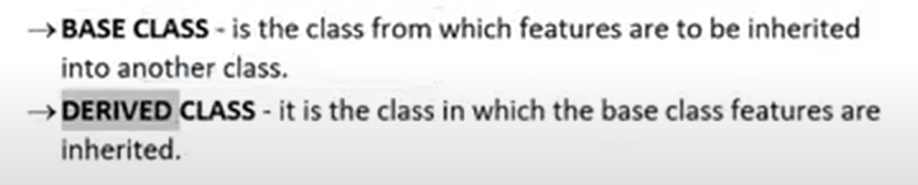

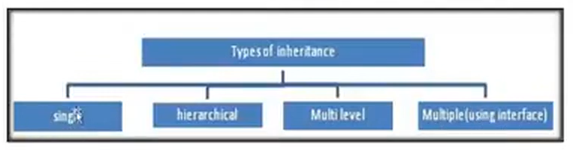

Four Types of Inheritance :

1. Single.
2. Heroical.
3. Multilevel.
4. Multiple (using interfaces).

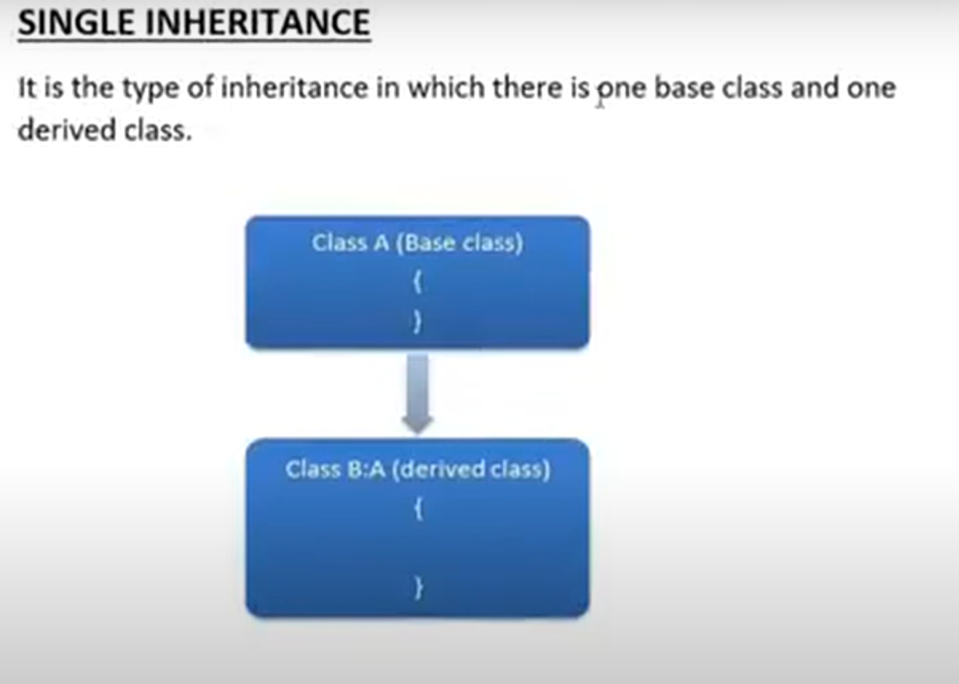

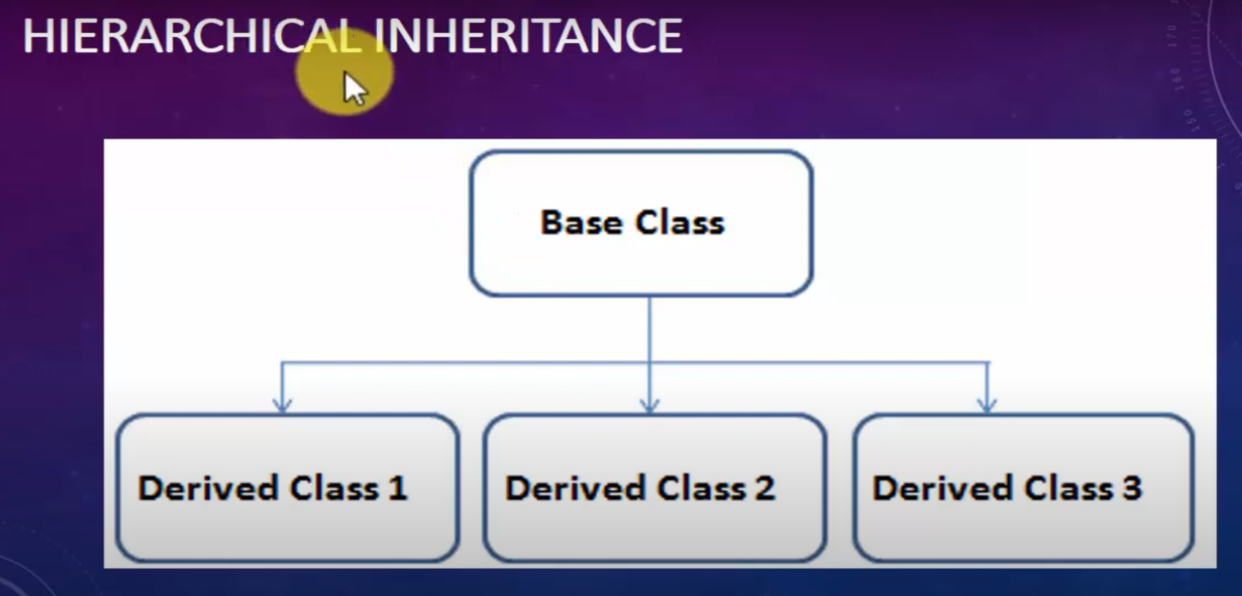

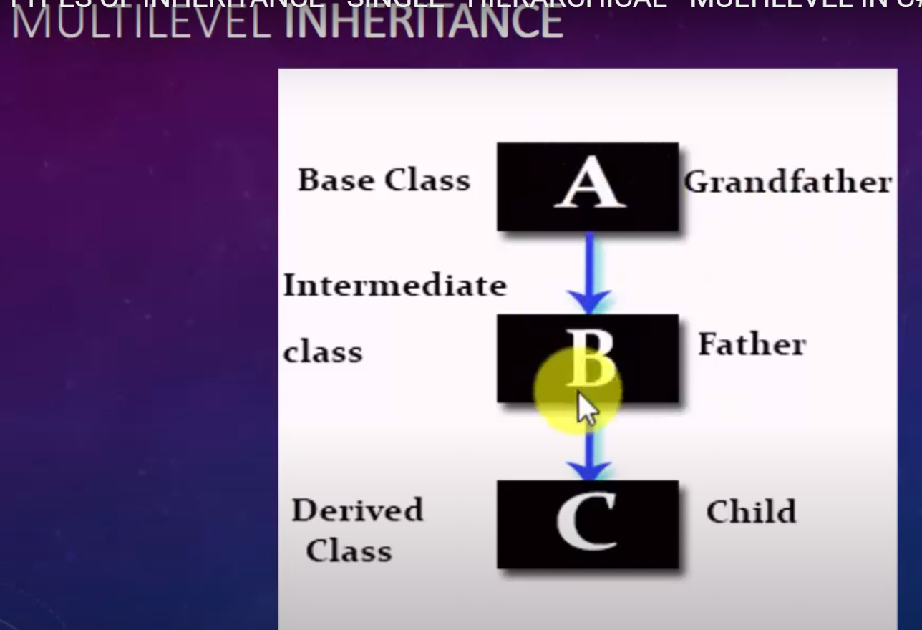

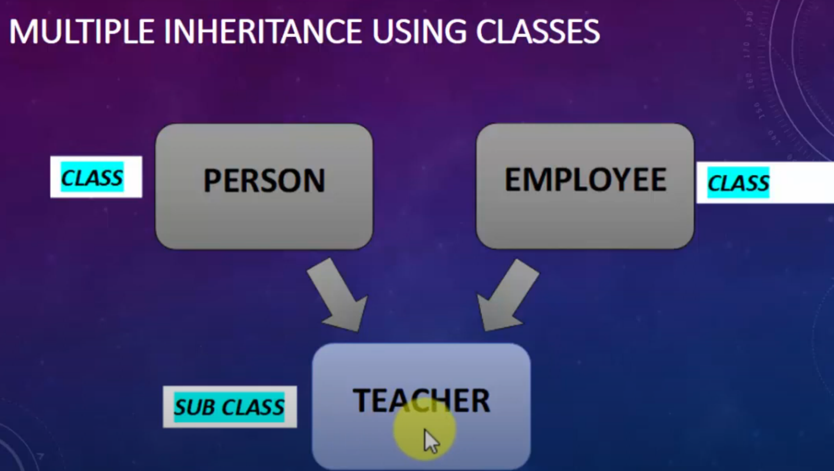

# Access Modifiers

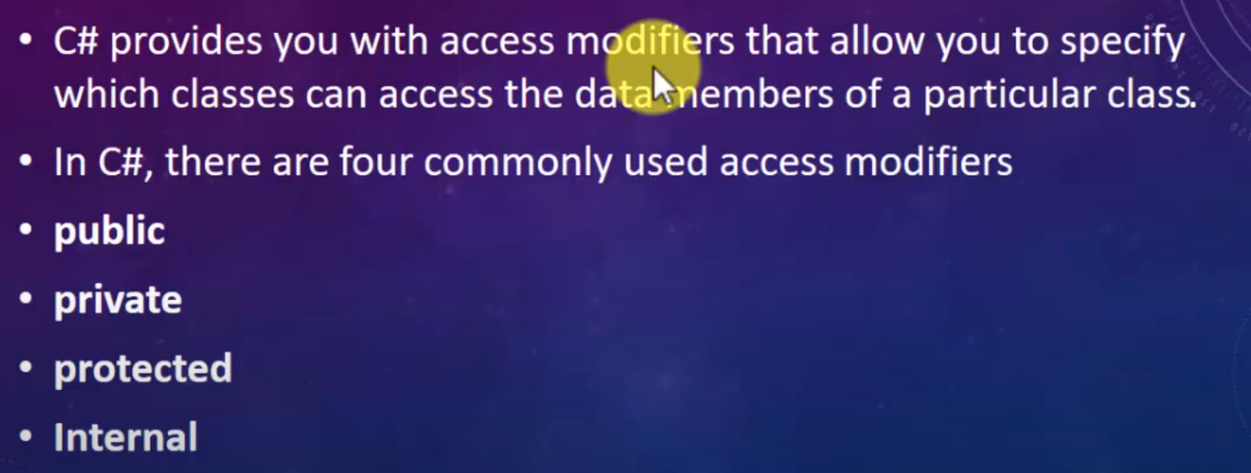

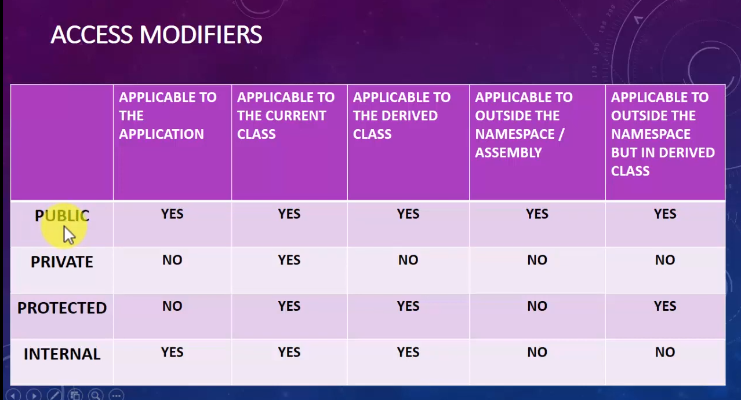

# Encapsulation

* Encapsulation in C# is a mechanism of wrapping the data (variables) and code acting on the data (methods or properties) together as a single unit.
* In encapsulation, the variables of a class will be hidden from other classes and can be accessed only through the methods or properties of their current class , therefore it is also known as data hiding.
* It is a protective shield that prevents the data from being accessed by the code outside the class.

### Benefit

* The field of a class can be made read only or write only
* A class can have total control over what is stored in its field

# Properties in C#

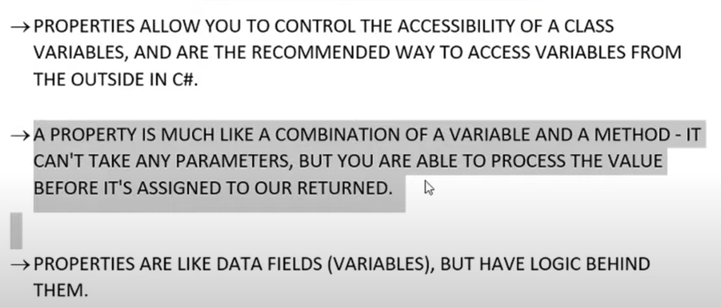

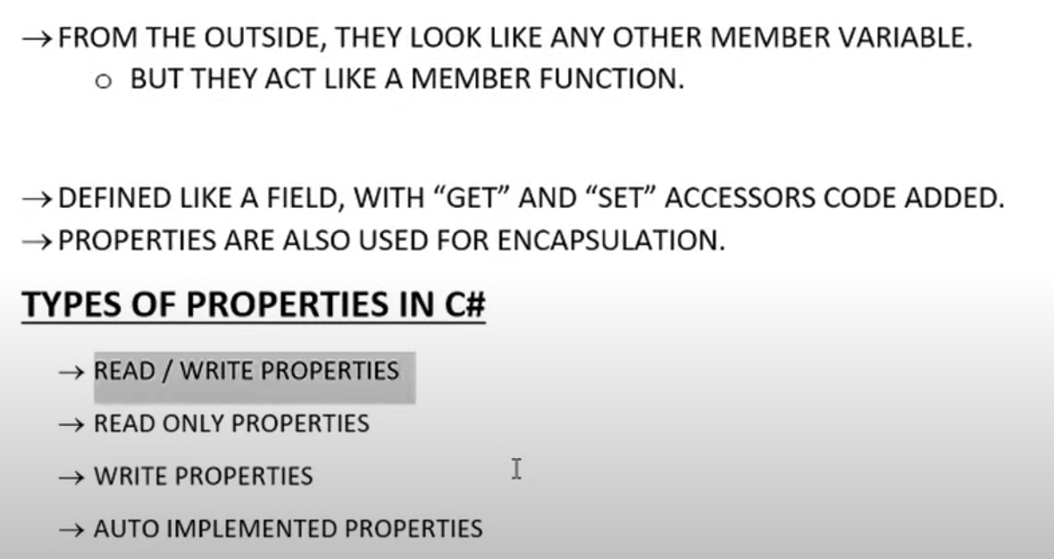

As in encapsulation, the data in a class is hidden from other classes, so it is also known as data-hiding. Encapsulation can be achieved by: Declaring all the variables in the class as private and using C# Properties in the class to set and get the values of variables.

# Static Properties in C#

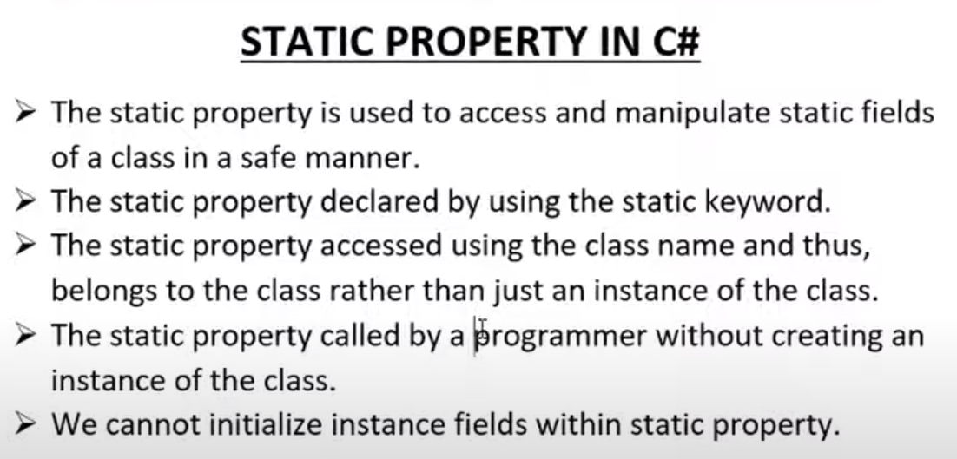

# Polymorphism

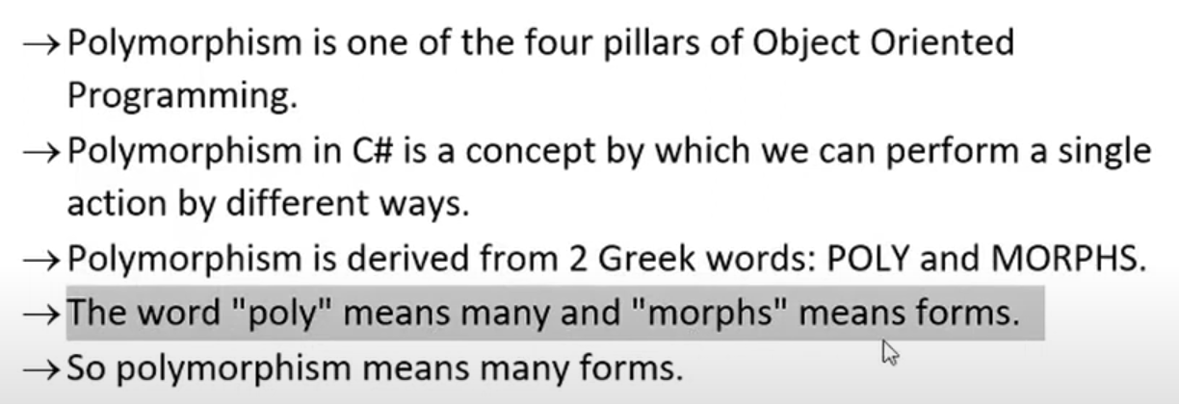

There are Two Types of polymorphism :

1. Static Polymorphism (Compile Time Polymorphism).
2. Dynamic Polymorphism (Run Time Polymorphism).

## Static Polymorphism:

* The mechanism of linking a function with an object during compile time is called static polymorphism or early binding.
* It is also called static binding
* C# provide two techniques to implement static polymorphism. They are

1. Method or Function Overloading.
2. Operator Overloading.

### Method or Function Overloading:

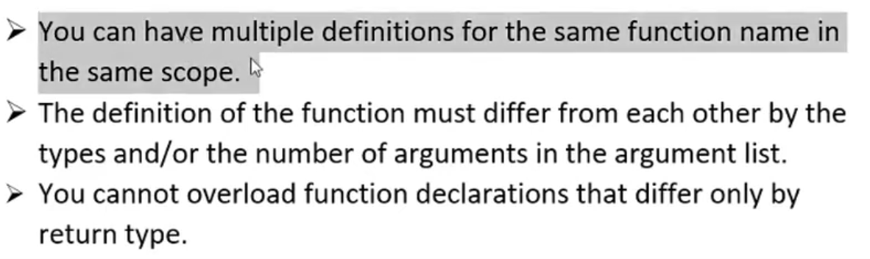

### Operator Overloading:

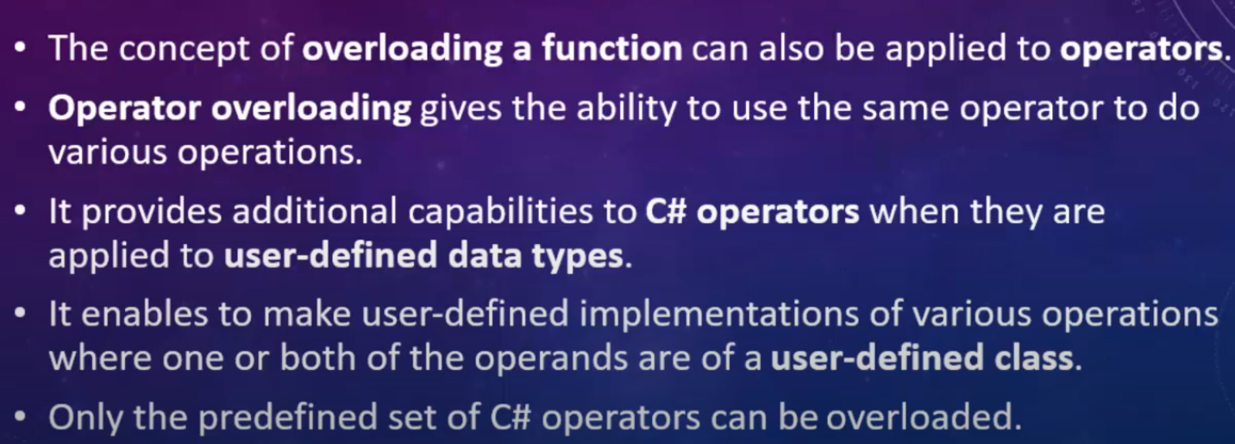

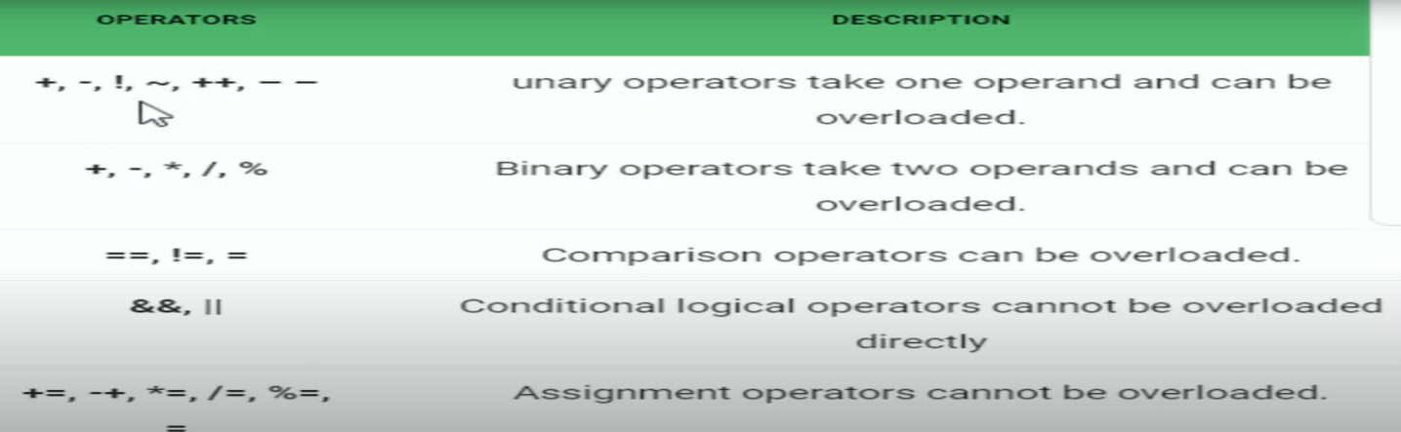

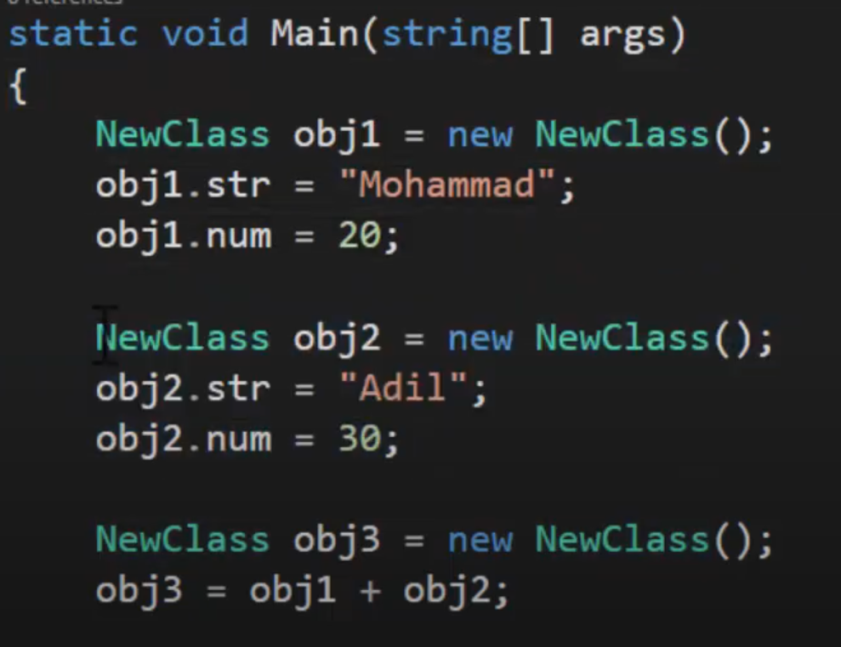

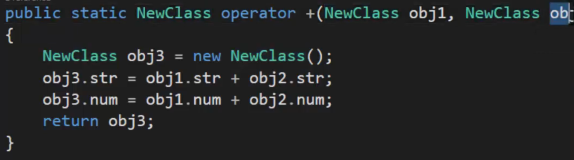

## Dynamic or Run Time Polymorphism :

* Run Time Polymorphism is achieved by method overriding.
* Method Overriding allows us to have virtual and abstract methods in the base derived classes with the same name and the same parameter.

### C# Method Overriding:

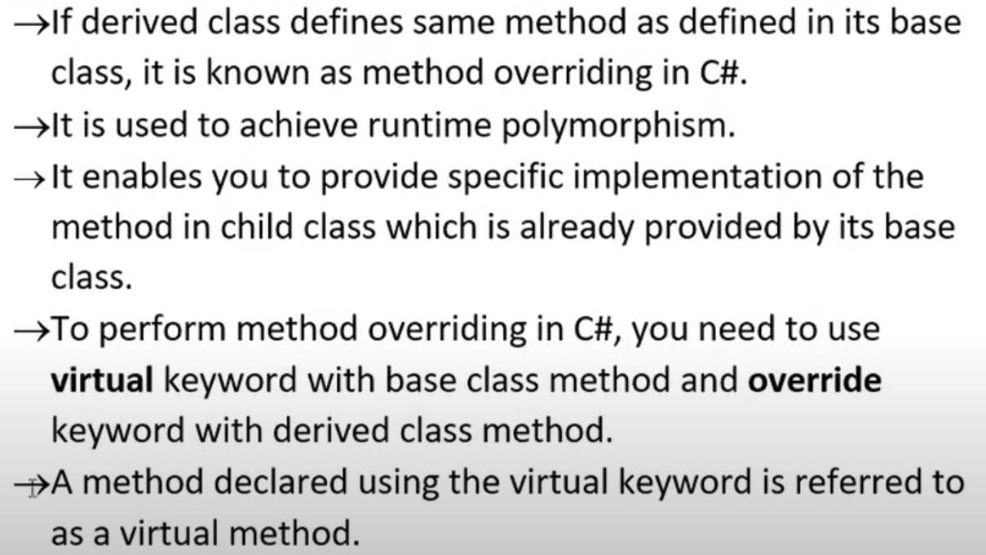

### 

# Method Hiding in C#

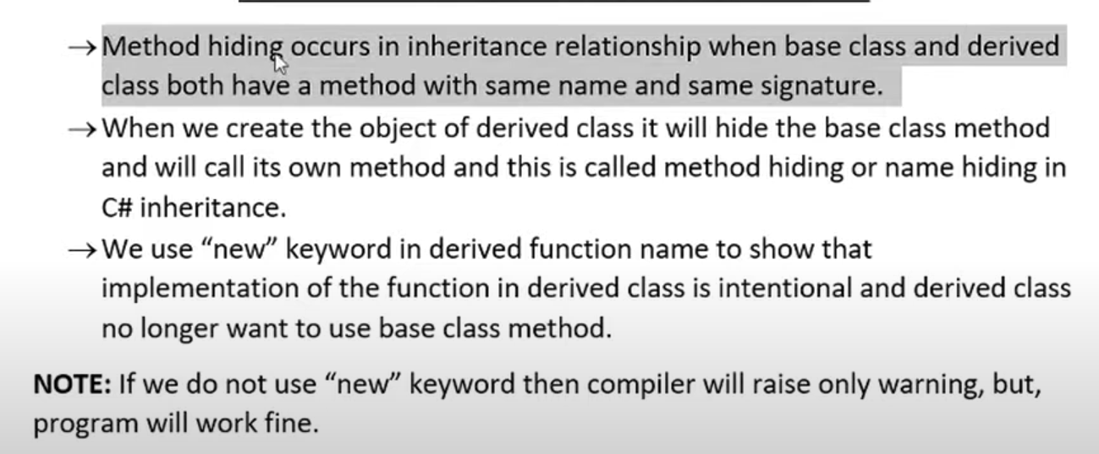

#### Different ways to call hidden base class member from derived Class

1. Use Base Keyword.
2. Cast child type to parent and invoke the hidden member. ((parent)c).show()
3. ParentClasss pc = new ChildClass(); pc.show();

# Difference b/w Method Hiding & Overriding

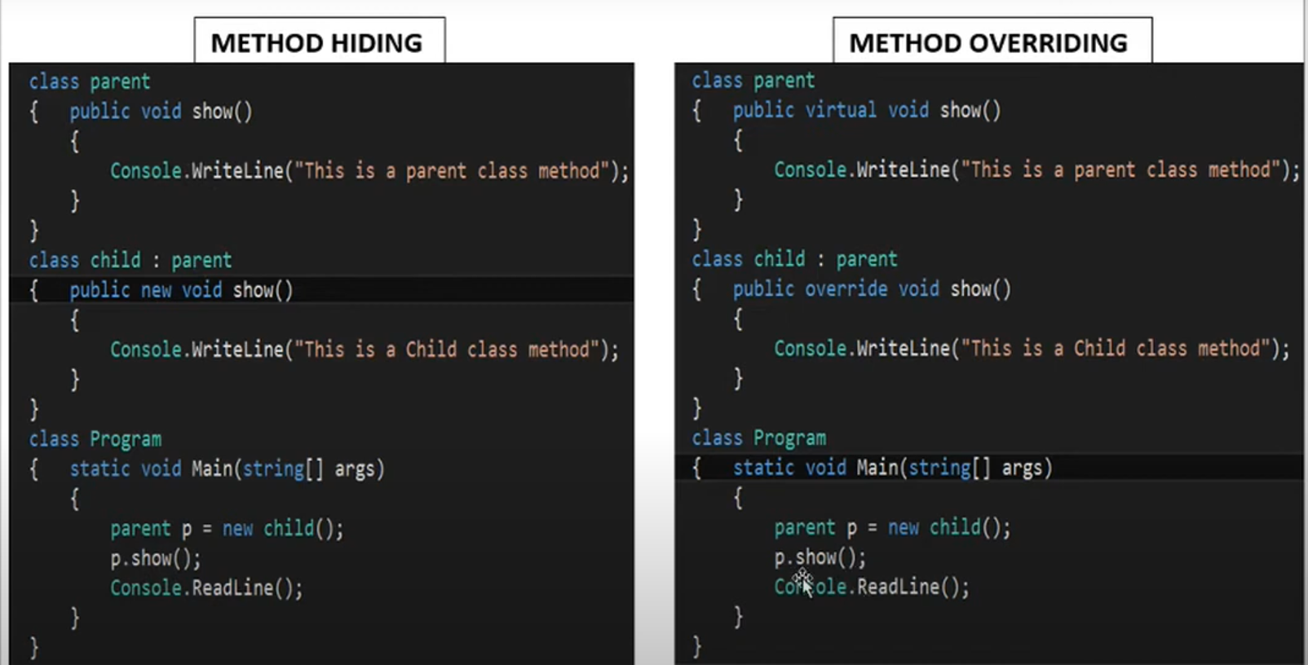

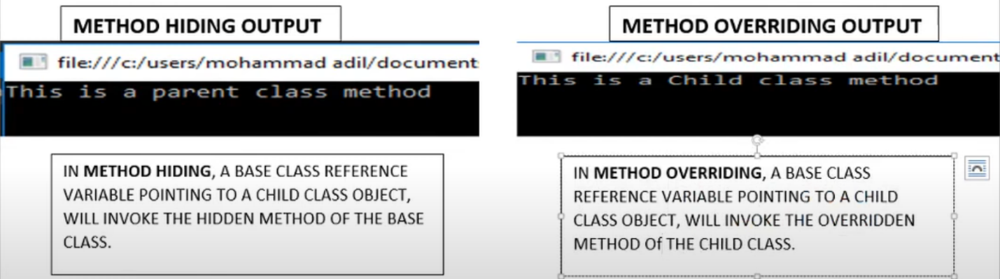

# Sealed Class

* The Sealed class can not become a parent class.
* The sealed class can be a derived class.
* It cannot become an abstract class.
* It sealed due to prevent the critical data stored in variables and method that child can override its method or change the data.

# Sealed Method

* When the derived class overrides a base class method , variable, property or event ,then new method , variable, property or event can be declared as sealed .
* Sealing the new method prevents the method from further overriding.
* Sealed method only available with method overloading not with method hiding.
* Sealed key word always write before overriding.

# Indexer in C#

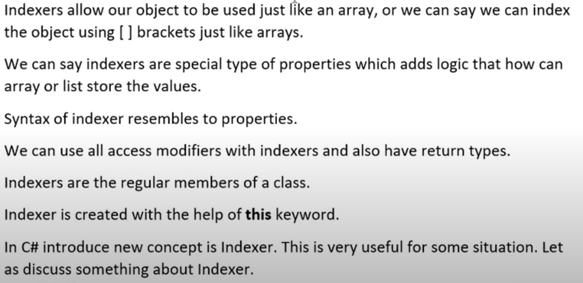

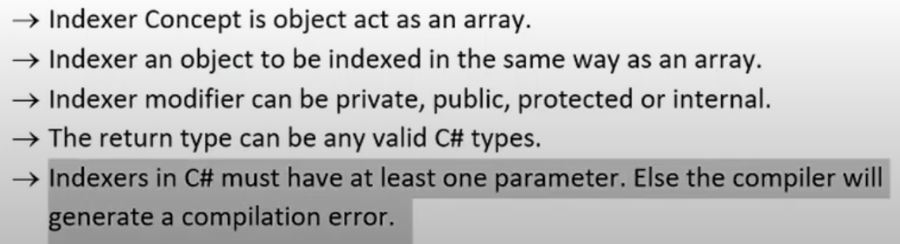

# Delegates in C#

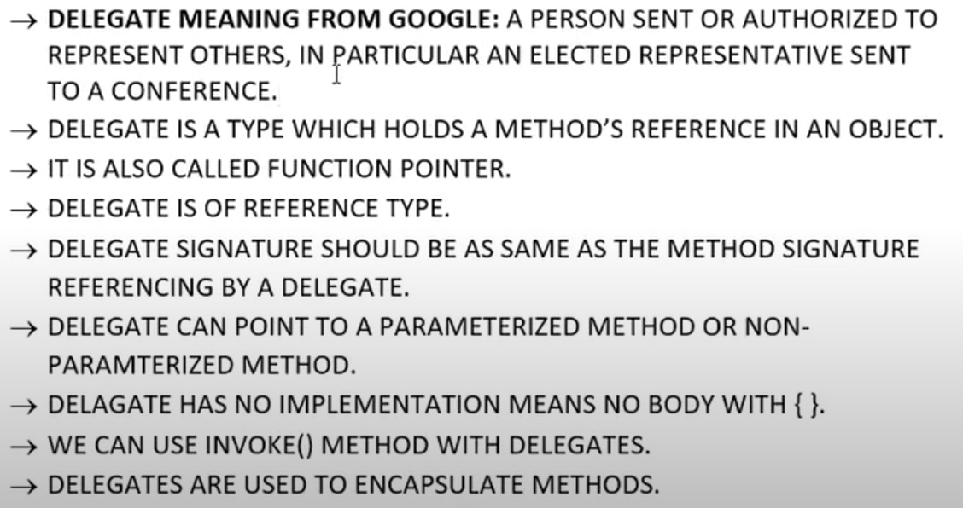

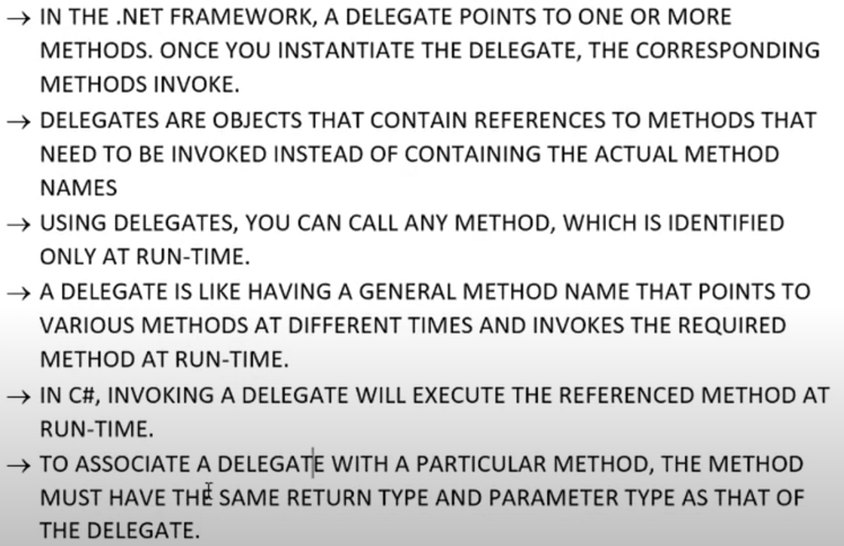

Instance Methods are invoked or called by an object ,So that’s why method referred by the delegates are static they are directly referenced by the class name

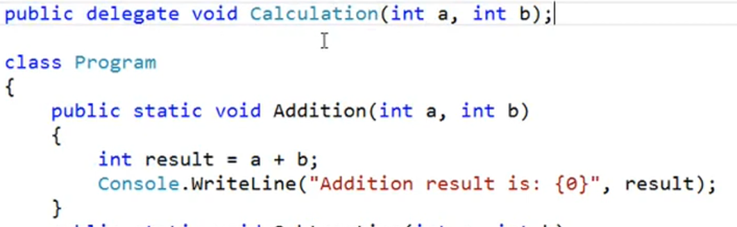

## Types Of Delegates:

1. Single Cast Delegates.
2. Multiple Delegates.
3. Multi Cast Delegates.

## Single Cast Delegate:

Single Cast delegate point to single method at a time. In this the delegate is assigned to a single method at a time. They are derived from System. Delegate Class

## Multiple Delegates:

In C#, A user can invoke multiple delegates within a single program. Depending on the delegate’s name or the type of parameters passed to the delegate, the appropriate delegate is invoked.

## Multi Cast Delegates:

* When a delegate is wrapped with more than one method that is known as a multicast delegate.
* In C#, delegate are multicast, which means that they can point to more than one function at a time. the are derived from System. Multi cast delegation.
* We can use += and -= assignment operators to implement multi cast delegation.

Calculation obj = new Calculation(Addition);

obj += Subtraction;

obj += Multiplication;

obj += Division;

# Anonymous Function in C#

* We discuss that delegates are used to reference any method that has the same signature as that of the delegation
* As the name suggest an anonymous method is a method without a name just the bode.
* Anonymous method in C# can be defined using the delegate key word
* It is introduced in C# 2.0

Public delegate void MyDelegate (int num);

MyDelegate obj = delegate(int a);

{

Body Of The Function

}

Function calling : obj(5)

## Function:

1. Anonymous method can be assigned to a variable of delegate type.
2. There is no return type of the Anonymous method, the return type of the delegation is the return type of anonymous method.
3. It does not have access modifier,
4. It is not static or instance method because it is made in main method.
5. It cannot contain jump statement like goto break continue.
6. It cannot access ref or out parameter.
7. Anonymous function can also pass as a parameter.

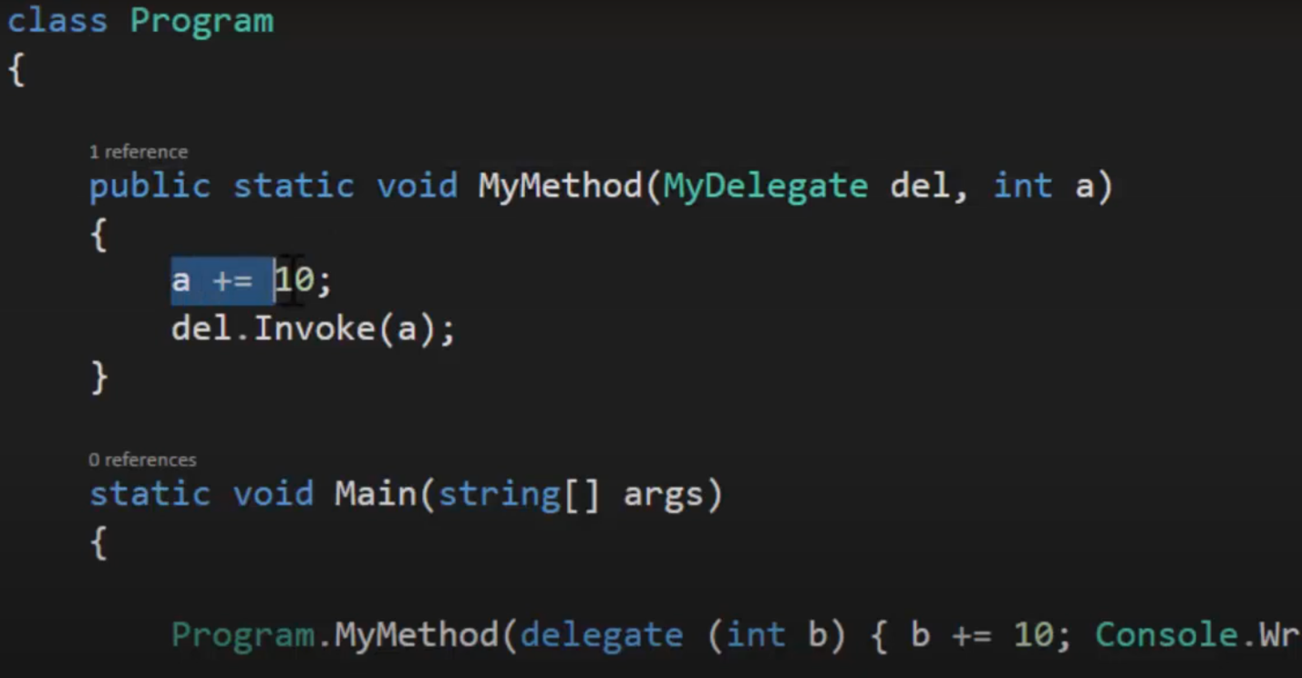

1. It can be event handler.

# Lambda Expression in C#

* Its is an advanced form of anonymous function.
* It is just like a JS arrow function.
* It is used use with delegates.

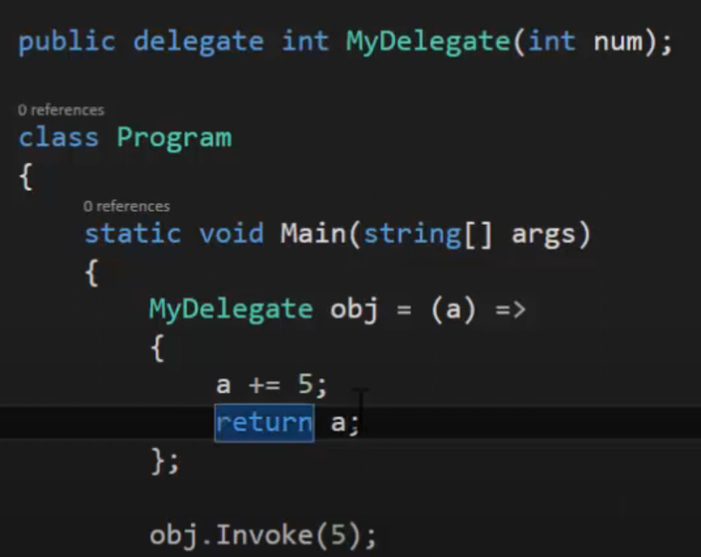

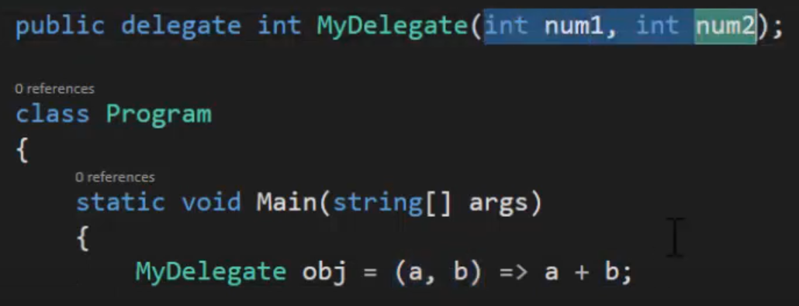

# Abstraction in C#

* Abstraction is used to hide the unnecessary information to outside world.
* It is a part of encapsulation.
* By using encapsulation techniques, we can achieve abstraction

# Abstract Class in C#

* The word abstract means a concept or an idea not associated with any specific instance. In programming we apply the same abstraction by making classes not associated with any specific instance.
* The abstraction is done when we need to only inherit from a certain class but not need to instantiate object of that class.
* In C# abstraction is achieved using Abstract Classes and interfaces.

## Properties of Abstract Classes:

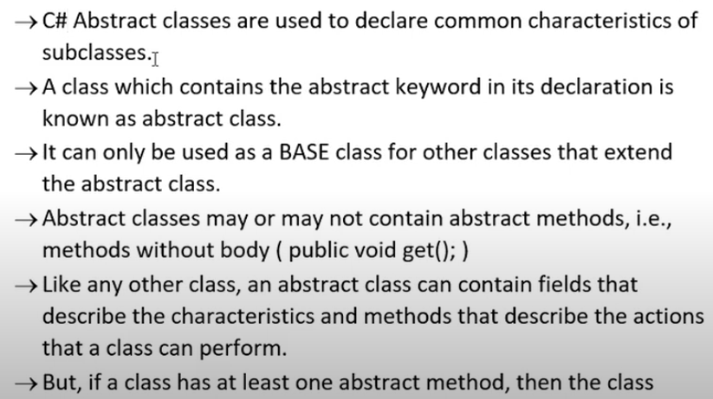

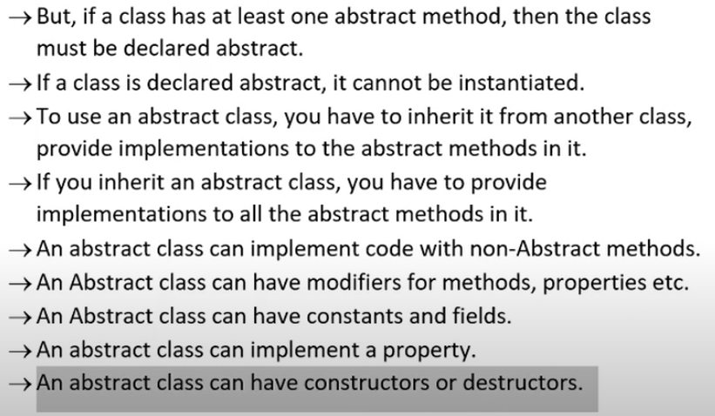

# Abstract Properties in C#

* The word Abstract means incomplete which means no implementation in programing.
* This duty of child class to implement an abstract member of their parent class.
* Declared by using the abstract key word.
* Contain only the declaration of the property without the body of the get and set accessors (which do not contain any statements and can be implemented in the desired class).
* Are only allowed in an abstract class.

# Interface in C#

* Methods in interface are abstract methods, properties, fields.
* You cannot initialize the variable in interface.
* Interface are used through inheritance.
* Members and Properties are public in interfaces.
* You can only define the method in interface body of the method will declare in the class it used.
* Interface can inherit other interfaces.
* A class that inherits this interface must provide implementation for all interface members in the entire interface inheritance chain.
* Interface reference variable can have the reference of their child class.

## Explicit or Implicit Interface Implementation:

* When you have two interfaces having the method with same name .Then we have to call one of them explicitly.

((i1)OBJ).Show Explicitly calling

OBJ.SHOW Implicitly calling

Public void i1.show(){} Explicitly Definition

Public void show(){} Implicitly Definition

# Generic in C#

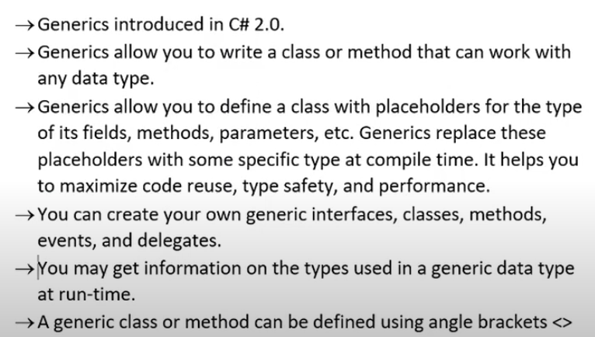

## Application

1. Interface.
2. Abstract Class.
3. Class.
4. Method.
5. Static Method.
6. Property.
7. Event.
8. Delegation.
9. Operator.

## Advantages

* Increase the reusability of the code.
* Generic are type safe. You get compile time errors if you try to use a different type of data than the one specified in the definition.
* Generic has a performance advantage because it removes the possibilities of boxing and unboxing.

# Generic Methods in C#

* Generic Method [process values whose data type are known only when accessing the variables that stores these values.
* Agenric method is declared with the generic type parameter list enclosed within angular brackets.
* Defining methods with type parameters allow you to call the method with a different.
* You can declare a generic method within generic or non-generic class declarations.
* It can be declared with the following keywords:

1. Virtual.
2. Override.
3. Abstract.

# Generic Class in C#

* Generic Classes define the functionality that can be used for any data type and are declared with a class declaration followed by a type parameter enclosed within angular brackets.
* Generic introduced in C#2.0 it allows you to define a class with placeholder for the type of its fields, methods, parameters etc. Generics replace these placeholders with some specific type at compile time.

# 